Movies: Setup
Database Initialization
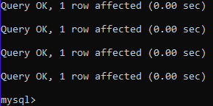

Show Tables
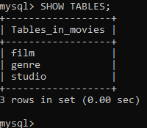

Python MySQL Test
